Task Name:- AIML Assignment- 13
Name:- Atharav Vijaykumar Kalore
Domain:- AI/ML
Branch:- Computer Engineering
Collage:- Dr. Panjabrao Deshmukh Polytechnic, Amravati.
Question no: 1
Program:
import numpy as np
# 1d Array
arr1 = np.array([10, 20, 30, 40, 50])

#2d Array
arr2 = np.array([[1, 2, 3],
[4, 5, 6],
[7, 8, 9]])

print("1D Array:")
print(arr1)
print("Shape:", arr1.shape)
print("Data Type:", arr1.dtype)

print("1D Array:")
print(arr1)
print("Shape:", arr1.shape)
print("Data Type:", arr1.dtype)

Output:
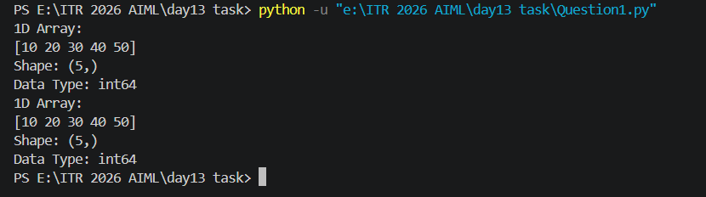

Question 2:
Program:
import numpy as np

zeros1 = np.zeros(8)

ones = np.ones((4, 4))

zeros2 = np.zeros((3, 3))

print("1D Array of Zeros")
print(zeros1)

print("\n4x4 Ones Matrix")
print(ones)

print("\n3x3 Zero Matrix")
print(zeros2)

Output:
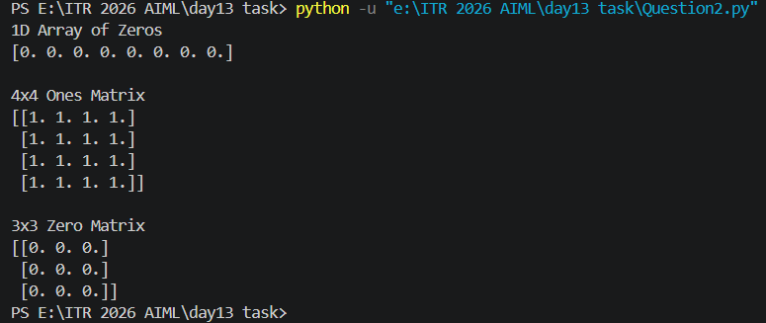

Question no3:
Program:
import numpy as np

a = np.arange(0, 21)

b = np.arange(10, 51, 2)

c = np.arange(5, 101, 5)

print("0 to 20")
print(a)

print("\nEven Numbers")
print(b)

print("\nMultiples of 5")
print(c)
Output:
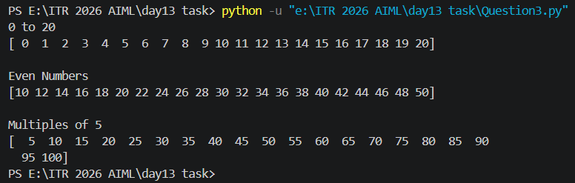

Question no 4:
Program:
import numpy as np

arr1 = np.linspace(0, 5, 10)
arr2 = np.linspace(-10, 10, 15)
print(arr1)
print("Length:", len(arr1))
print()
print(arr2)
print("Length:", len(arr2))
Output:
